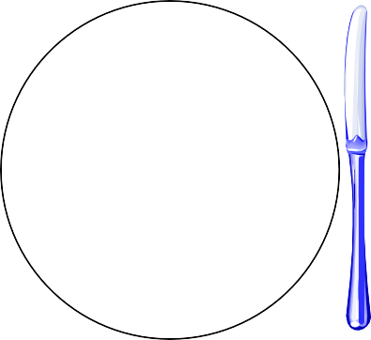

**Formal Table Setting**

Napkin

Knife, Spoon

Forks

Salad, Dinner, Dessert

Cup & Saucer

Dinner Plate

Milk Glass

Water Glass

Salad

Bread & Butter Plate